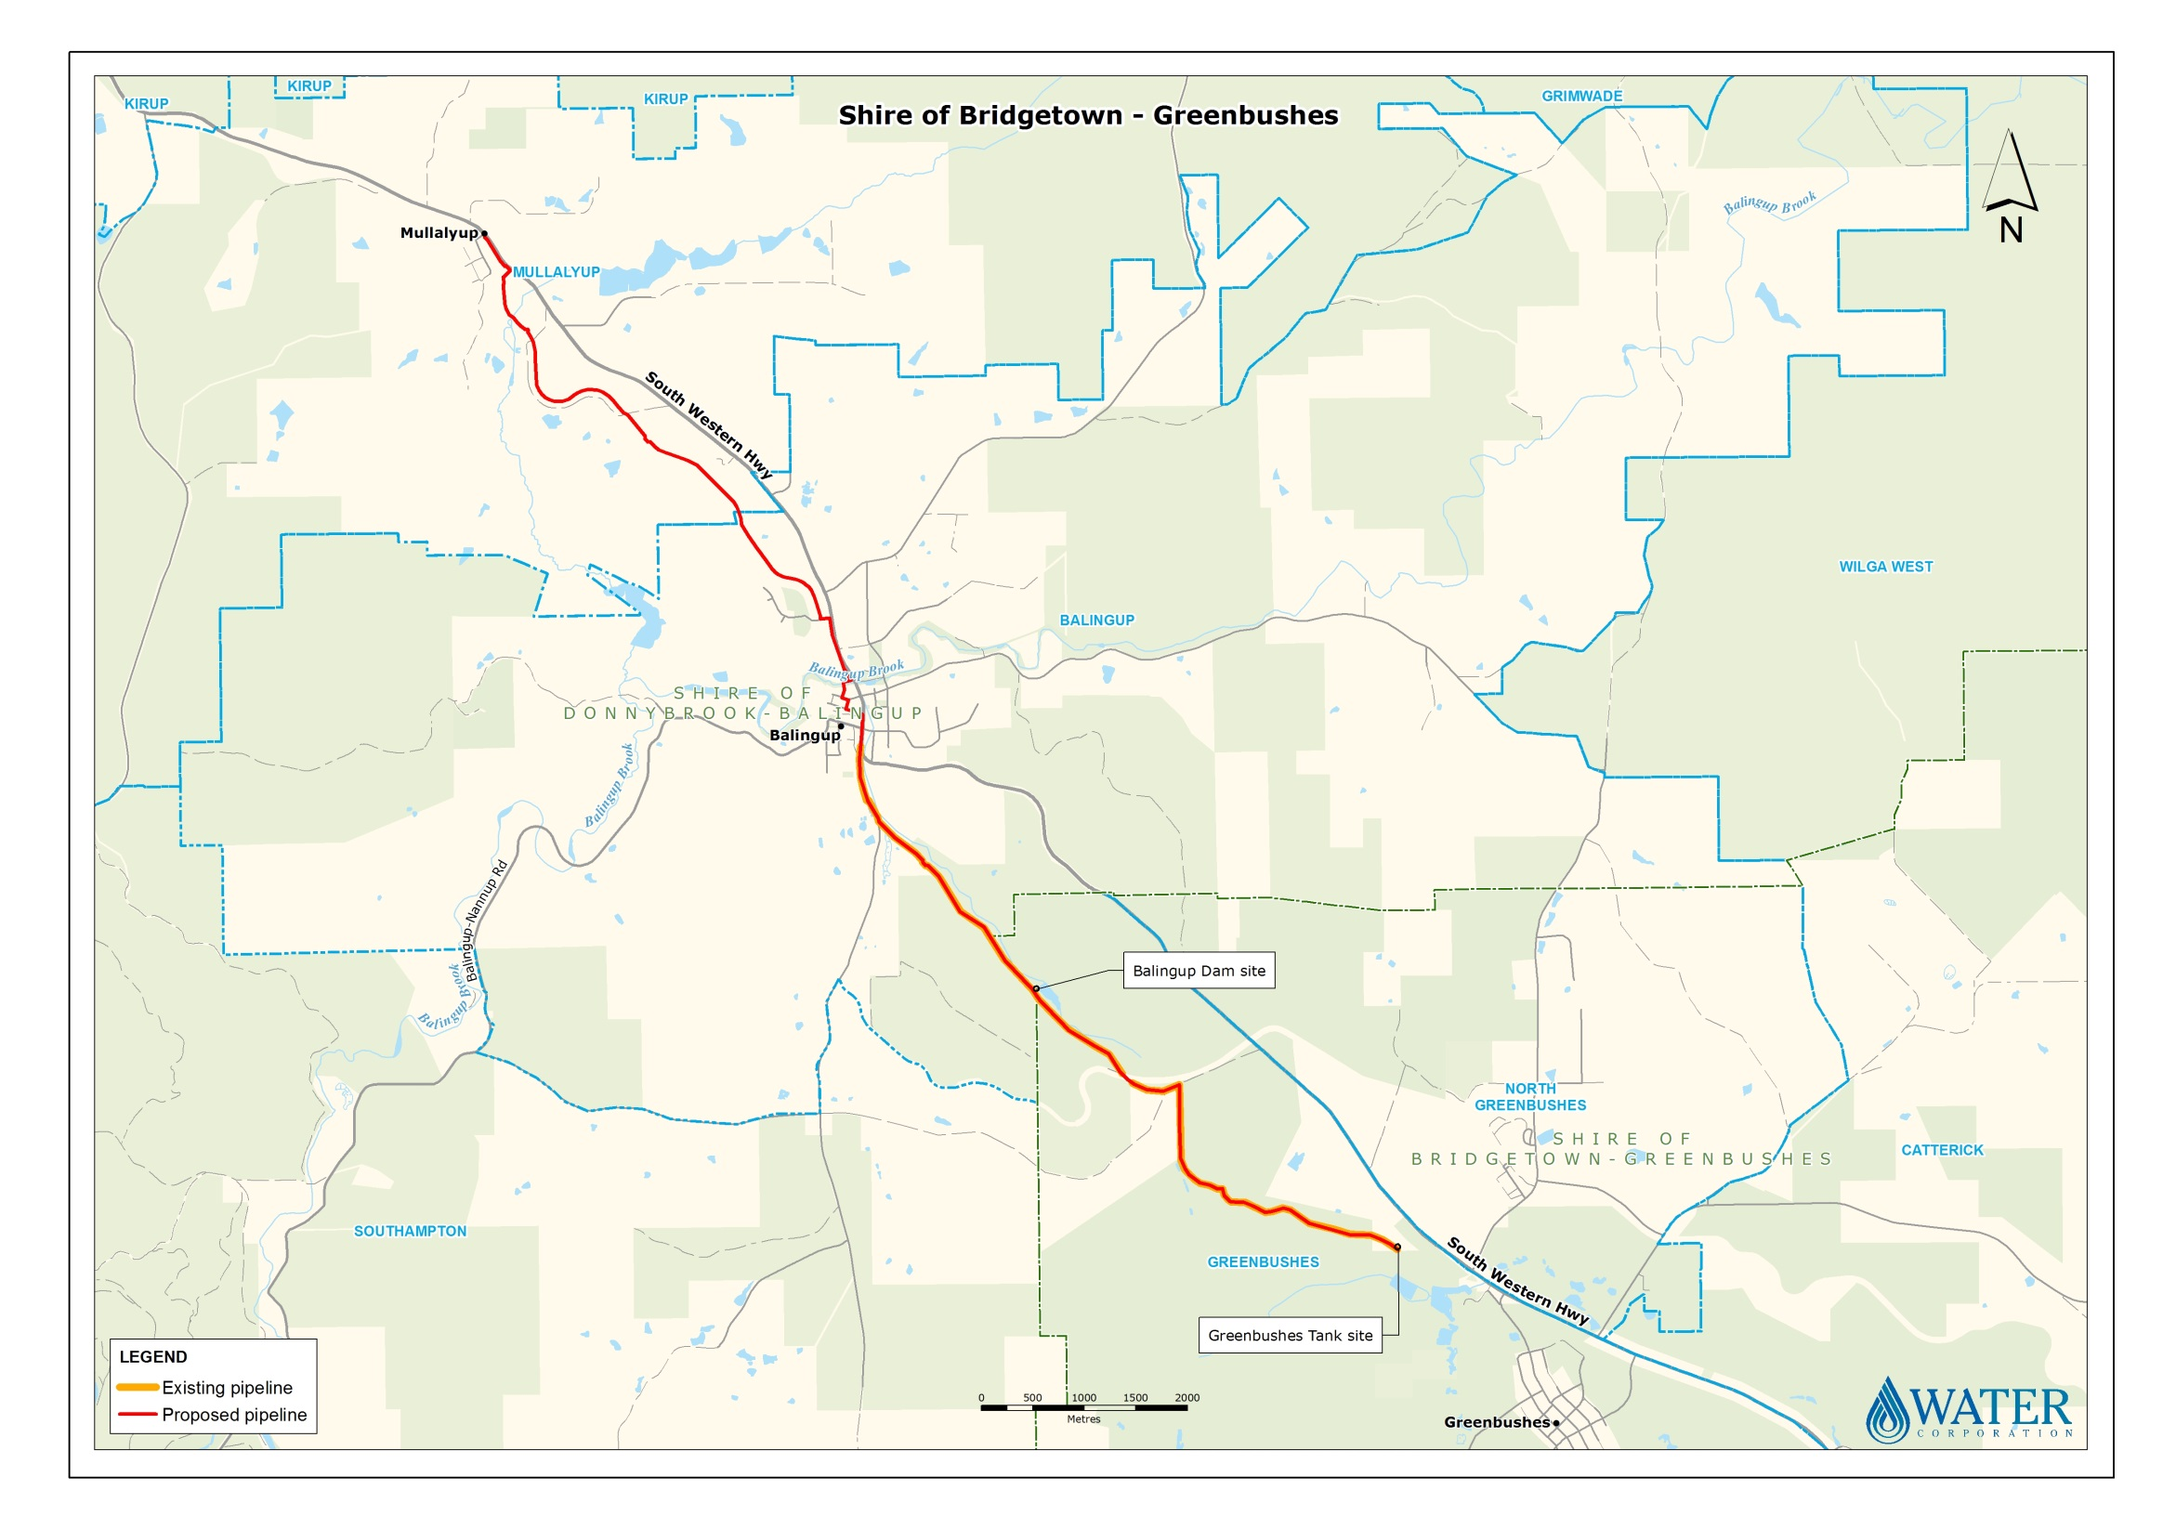

* Water Corporation plans to install a new water pipeline between Greenbushes and Mullalyup. This project will also have associated work at Water Corporation tank sites.
* The purpose of this project is to improve the supply of water to the towns of Balingup, Mullalyup and Kirup, by connecting them to the Bridgetown Regional Water Supply Scheme.
* The project includes:
* The installation of approximately 16kms of water pipeline;
* Work on the water tanks located at Balingup Dam, Mullalyup South-West Highway and Kirup Dam.
* Work will commence in 2020, and continue for a period of 18 months.
* Please view instructions in the attached letter if you would like to raise any objections to the proposed work.