Waterwise Office Program

Annual Report

**Business Name:**

Address:

Telephone:

Email:

Date:

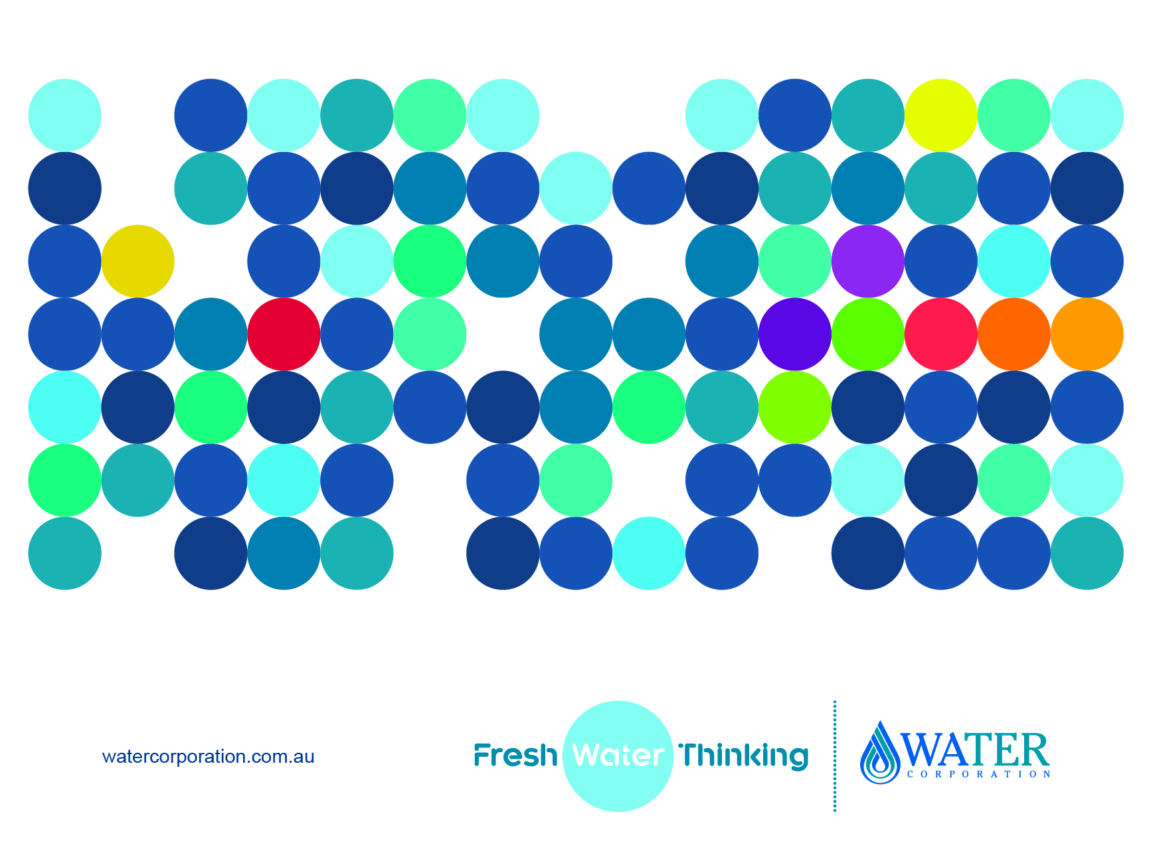



# Annual Reporting

Annual Reports to provide feedback on the progress of your water efficiency initiatives are required to remain endorsed as a Waterwise Office and to be eligible for the annual Waterwise Office Program Recognition Scheme.

Please refer to your Water Management Plan and/or previous Annual Report and provide an update on the progress by completing the Action Plan Table and Water Savings – Scheme Table in this document. Additional action items can be added as opportunities arise for your business to implement initiatives.

If you require assistance completing your report, please contact the Water Efficiency Program Coordinator on 9420 2706 or email [Water.Efficiency@watercorporation.com.au](mailto:Water.Efficiency@watercorporation.com.au)

**Please email your annual report submission to:** [Water.Efficiency@watercorporation.com.au](mailto:Water.Efficiency@watercorporation.com.au)

Or post to:

Non Residential Water Efficiency

Water Corporation

PO Box 100

Leederville WA 6007

# Annual Report - Water Saving Action Plan

**Please note:** Refer to your WMP and/or previous Annual Report action table to **update the status** of the initial actions and **add** any new items. Please do not delete any of the initial actions.

Refer to <https://www.watercorporation.com.au/home/business/saving-water/water-saving-tips> for a list of water saving tips that may be appropriate for your office building.

|  |  |  |  |
| --- | --- | --- | --- |
| Water Saving Action Areas  Operational Efficiency and Conservation  Water Re-use and Wastewater Management  Education and Awareness | Commentary  (Including estimated saving if known) | Proposed Completion Date | Status  (Complete, Ongoing, To be completed or N/A ) |
| **Short term (low cost, payback less than 12 months)** | | | |
| *E.g. Display water saving educational material, reduce hand basin tap flow rates to 4.5L/minute or less.* |  |  |  |
|  |  |  |  |
|  |  |  |  |
|  |  |  |  |
|  |  |  |  |
|  |  |  |  |
| **Long term (higher cost, payback greater than 12 months)** | | | |
| *E.g. Install dual flush toilets as part of floor refurbishment.* |  |  |  |
|  |  |  |  |
|  |  |  |  |
|  |  |  |  |
|  |  |  |  |
| **Ongoing actions** | | | |
| *E.g. Daily meter reads, review data logger results daily, online water efficiency training with Water Corporation; Cooling tower water efficiency.* |  |  |  |
|  |  |  |  |
|  |  |  |  |
|  |  |  |  |
|  |  |  |  |
|  |  |  |  |
|  |  |  |  |
|  |  |  |  |
|  |  |  |  |
|  |  |  |  |

# Water Savings – Scheme Water Only

|  |  |  |
| --- | --- | --- |
| WATER USE DETAILS Water savings – Scheme water  (Please refer to your most recent WMP/Annual Report to complete the following details) | | |
| **Company Details** | | |
| **1. Business name:** | |  |
| **2. Account number:**  **(Found on Water Corporation bills)** | |  |
| **3. Cooling Type:** | | Air cooled/Water Cooled |
| **Previous Report Information** | | |
| **4. Previous reporting year (FY)** | [2016-2017] | |
| **5. Water use (kL)** |  | |
| **6. Historical benchmark (based on previous reporting year)** |  | |
| **7. Target benchmark** |  | |
| **Annual Reporting Information** | | |
| **8. Annual reporting year** | | [2017-2018] |
| **9. Water use (total water use for 2017-2018)** | |  |
| **10. Net lettable area (m2)** | |  |
| **11. Actual benchmark achieved** | |  |
| **12. Has target benchmark been** **achieved** | | Yes/No |
| **13. Explain background for increase or decrease in water use)** | |  |
| **Next Reporting Year Benchmark Target Information** | | |
| **14. New target benchmark (2018-2019)** |  | |
| **14a. Explanation of new target** |  | |

Table: Water Savings – Scheme Water Only

1. **Waterwise Recognition Categories**

The following recognition categories have been established for the Waterwise Office Program

|  |  |  |
| --- | --- | --- |
|  | Water cooled  (kL/m2/annum) | Air cooled  (kL/m2/annum) |
| Bronze (industry baseline) | 0.86 | 0.71 |
| Silver | 0.75 | 0.61 |
| Gold** | 0.61 | 0.48 |
| Platinum** | 0.48 | 0.35 |

Table: Waterwise Office Program Recognition Categories

**In order to be eligible to receive Gold or Platinum levels of recognition, a current NABERS Water Rating is required. This simply provides an independent validation of the results of high performing buildings before they are recognised as such.

# Annual Report Accuracy and Acceptance

|  |  |  |  |
| --- | --- | --- | --- |
| The information provided in this document is an accurate representation of [Business Name]’s target indicator(s), contained in the WMP and previous Annual Report.  *(Program participant to complete)* | | | |
| **Name:** | [Contact that is responsible for site water management; refer to table 1] | **Position:** |  |
| **Phone number:** |  | **Mobile number (if applicable):** |  |
| **Email:** |  | | |
| **Signature:** |  | | |
| **Date:** |  | | |
|  |  | | |
| **Water Corporation Acceptance** | | | |
| **Name:** |  | | |
| **Position:** |  | | |
| **Signature:** |  | | |
| **Date:** |  | | |