INSPECTION TEST AND PLAN Canusa Aqua -Shield Heat Shrink Sleeve
Contractor/Customer: ABBC Engineering | Date of issue: 1st March 2022
Project Title: Subiaco Treatment Plant | Prepared By: Joe Bloggs
Water Corp Project No.: CW 1999999 | Job/Contract Number: 1000000
Description and System: DN1200 pipe Subiaco | No. of Pages: 3
Legend of Inspection Points:
H = Hold Point work may not proceed without approval or notification, unless approved by Principal or contractor.
W = Witness Point. Work may proceed without the presence of the Principal
S = Surveillance. Witness at random, no Formal Notification Required
V = Verify
R/A = Review Documents & Accept.
(work can proceed if principal cannot attend Hold point inspection within three hours of notified time for attendance)

STEP 1. BATCH NUMBERS
Product Name: | UCC Protek Butyl (Multi) Primer | UCC Butyl Mastic | Canusa Heat Shrink Sleeve
Batch Numbers:
Technical Specification Verification – DS95
L2 - Coating Specification. Heat shrink sleeve
External field joint coatings AS4822:2018

Steps | Activity/Operation | Person Responsible | Inspection & Verification Points
 |  |  | Sub-  Contractor | Sign | Contractor | Sign | Principal or nominee | Sign
Step 2. | SURFACE PREPERATION
1 | Ensure that the mainline coating edges are bevelled to 30°. Clean oil, grease, or other surface contaminants from the exposed steel and adjacent pipe coating with a solvent cleanser such as MEK or Isopropyl Alcohol. | Supervisor/ QC Inspector | V |  | S |  | S
2 | Ensure that the pipe is dry before cleaning. Using a power wire brush or a flapper disc, abrade the pipe to a minimum of St2/SP2, generating a coarse finish.  Ensure any preservation coating is removed from Sintakote and the exposed cutback section adjacent to tie in weld.  Using a 60-80 grit sandpaper lightly abrade Sintakote adjacent to the cutback area to a distance of 150mm (6”) beyond each end of the sleeve width. | Supervisor/ QC Inspector | V |  | S |  | S
3 | Wipe clean or air blast the steel and coated areas to remove foreign materials. | Supervisor/ QC Inspector | V |  | S |  | S
4 | Pre-heat the joint area to 40-60°C. and using a suitable contact-probe thermometer, ensure that the correct temperature is reached on the steel and at least 150mm (6") on each side of the sleeve.  Where the required 40-60°C pre-heat cannot be achieved on charged water mains, the cleaned steel and abraded Sintakote are to be coated with UCC Protek Butyl (Multi) Primer. Primer to be tack dry before sleeve install commences. | Supervisor/ QC Inspector | V |  | S |  | S
Step 3. | PROFILING TRANSITIONS WITH UCC BUTYL MASTIC
1 | Where it is required to profile transitions with UCC Butyl Mastic Strip, first stripe coat this area with UCC Protek Butyl (Multi) Primer. Allow primer to become tack dry to touch. Only reapply primer if it becomes dust contaminated prior to application of sleeve. | QC Inspector | V |  | S |  | W
2 | Weld beads, convex collar step-downs and other transition points SHALL be profiled using UCC Butyl Mastic Strip to provide a void-free, profiled contour across the transition. Refer to the custom video for profiling of convex band tapping fittings. |  | W |  | W |  | W
Step 4. | SLEEVE INSTALLATION
1 | Cut the lead in chamfer on sleeve, partially remove the release liner and gently heat the underlap approximately 150mm (6") from the edge. | QC Inspector | V |  | S |  | W
2 | Centre the sleeve over the joint so that the sleeve overlaps between the 10 and 2 o'clock positions. Press the underlap firmly into place and remove the remaining release liner. | QC Inspector | V |  | S |  | W
3 | Wrap the sleeve loosely around the pipe, slight sag on bottom of the sleeve, ensuring the appropriate overlap. Gently heat the backing of the underlap and the adhesive side of the overlap. Press the overlap into place. | QC Inspector | V |  | S |  | W
4 | Cut approx. 25mm radius on each corner of closure patch and gently heat the underside of closure patch to soften adhesive. Centre the closure patch on the overlapping sleeve, press down firmly. | QC Inspector | V |  | S |  | W
5 | Gently heat the closure and pat it down with a gloved hand. Repeating this procedure, move from one side to the other. Smooth any wrinkles by gently working them outward from the centre of the closure with a roller. | QC Inspector | V |  | S |  | W
6 | Pipe OD: ≤600mm (24"): 1 torch  Pipe OD: >600mm (24"): 2 torches RECOMMENDED  Pipe OD: >900mm (36"): 2 torches MANDATORY  Pipe OD: >1830mm (72"): 3 torches MANDATORY  Using the UCC Auto Ignition Gas Torch Kit with 50mm Burner Head, begin at the centre of the sleeve and heat circumferentially around the pipe. Use broad strokes. If utilizing two torches, operators should work on opposite sides of pipe. | QC Inspector | V |  | S |  | W
7 | Continue heating from the centre toward one end of the sleeve until recovery is complete. In a similar manner, heat and shrink the remaining side. | QC Inspector | V |  | S |  | W
8 | Shrinking has been completed when the adhesive begins to ooze at the sleeve edges all around the circumference. Finish shrinking the sleeve with long horizontal strokes over the entire surface to ensure a uniform bond. | QC Inspector | H |  | S |  | W
9 | While the sleeve is still hot and soft, use a hand roller to gently roll the sleeve surface and push any trapped air up and out of the sleeve where required. If necessary ,reheat to roll out air. | QC Inspector | V |  | S |  | W
10 | Continue the procedure by also firmly rolling the closure with long horizontal strokes from the weld outwards. | QC Inspector | V |  | S |  | W
Step 5. | INSPECTION, HOLIDAY TESTING & REPAIR
1 | Visually inspect the installed sleeve for the following:  - Sleeve is in full contact with the steel joint.  - Adhesive flows beyond both sleeve edges.  - No cracks or holes in sleeve backing.  - Emboss on Aqua-Shield has ghosted out. | QC Inspector | H |  | V |  | W
2 | Using a brush-type holiday detector, the entire surface of the coated joint shall be checked for holidays or other discontinuities in accordance with AS 3894.1, using a test voltage of 11kV. | QC Inspector | H |  | H |  | H
3 | Holidays shall be repaired by removing the defective sleeve and applying a CRP65 repair patch or a replacement heat shrink sleeve. | QC Inspector | H |  | V |  | V
4 | Upon completion of sleeve installation, the applicator is required to place their initials and certification ID (written in paint marker) to the side of the sleeve. |  | H |  | W |  | W
Step 6. | FIELD PEEL TEST – AS 4822:2018 APPENDIX B
1 | The peeling test for ambient temperature shall be performed at 23±3°C. | QC Inspector | H |  | V |  | W
2 | The temperature shall be measured by an adapted probe, on the external surface of the joint at the root of the peeled strip (evaluation on 100 mm). | QC Inspector | H |  | V |  | W
3 | A suitable sample of 25mm width x min. 150mm length shall be cut. | QC Inspector | H |  | V |  | W
4 | The strip shall be separated over a circumferential length of approx. 20 mm. | QC Inspector | W |  | V |  | W
5 | The separated part of the coating shall be secured in the clamp of the spring balance and peeled off with a peeling rate of 100 mm/min, perpendicular to the surface of the pipe.  The evaluation length of 100 mm shall be completed within 55 s to 65 s.  The peel force shall be recorded over a distance of 10 mm every 6 s. | QC Inspector | H |  | H |  | H
6 | The peel strength shall be calculated as the average of the readings taken above.  For a 25mm wide test sample, at least 5 kg. average peel strength @23°C on a spring gauge (50 N as per AS4822.2018 Table 6.1) has to be achieved. | QC Inspector | H |  | H |  | W
Step 7. | COATING REPAIR OF PEEL TEST ZONE
1 | Following the peel test, coating repair to effected per Installation Guide - CRP65 Repair Patch and UCC Butyl Mastic Filler (IG_NA_CRP65.pdf). | Supervisor/ QC Inspector | V |  | V |  | W
Step 8. | STORAGE & BACKFILLING
1 | Where the fitting is to be stored outdoors for longer than 1 week (before installation and backfilling), the fitting/pipe must be covered with a tarp. | Supervisor/ QC Inspector | H |  | V |  | W
2 | After shrinking is complete, allow the sleeve to cool to ambient temperature. To prevent damage to the sleeve during backfilling, use selected backfill material, (no sharp stones or large particles) otherwise UCC RockShield mesh should be used. | Supervisor | W |  | V |  | W

ITP Reviewed and Accepted for Issue |  | Name | Signature | Date
Sub-Contractor
Contractor/Client
Principal | Water corporation

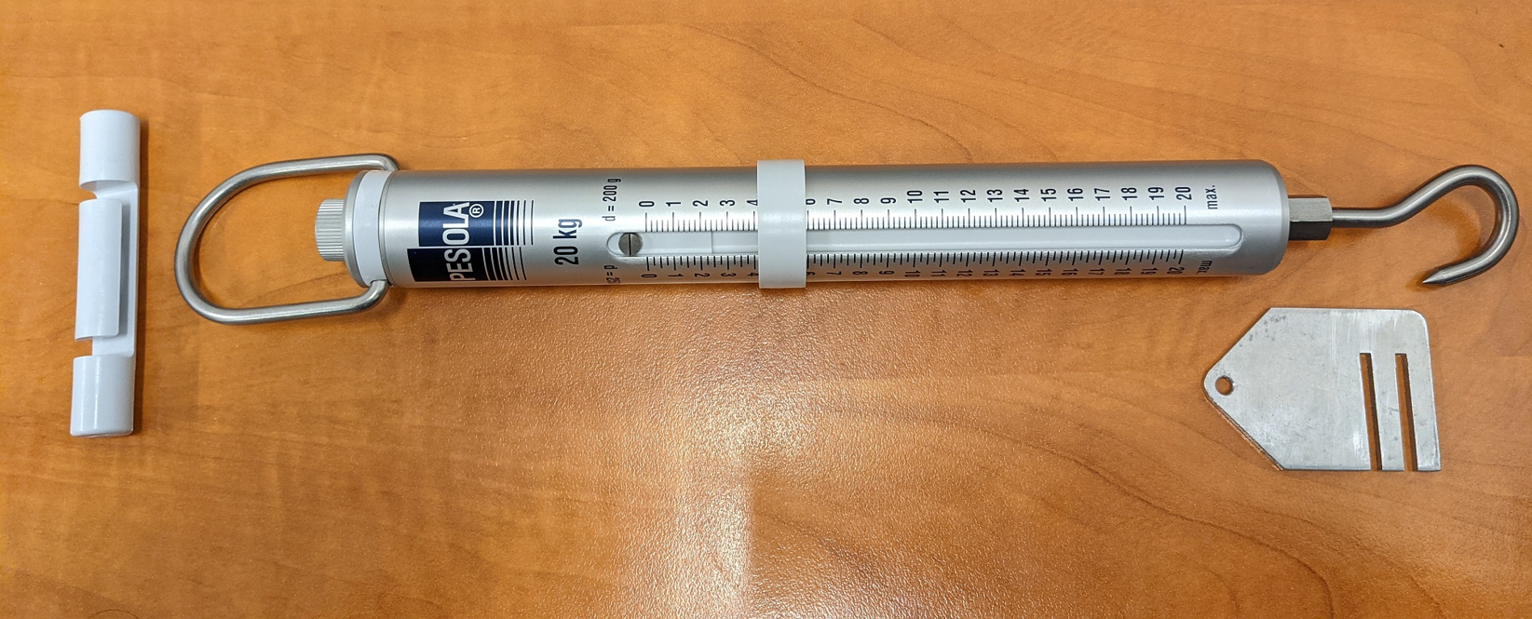
Force, Spring Peel Testing Device

